

Implicit heap-dynamic variables are bound to a type at runtime. Dynamic type binding is the act of binding a type to a variable at runtime. Therefore, the relationship between the two is that implicit heap-dynamic variables use dynamic type binding.

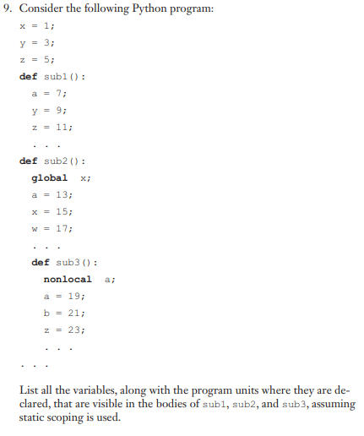

9:

**Variable Declared**

**sub1:**

a=7 sub1

y=9 sub1

z=11 sub1

x=1 main

**sub2:**

a=13 sub2

x=15 sub2

w=17 sub2

y=3 main

z=5 main

**sub3:**

a=19 sub3

b=21 sub3

z=23 sub3

w=17 sub2

x=15 sub2

y=3 main

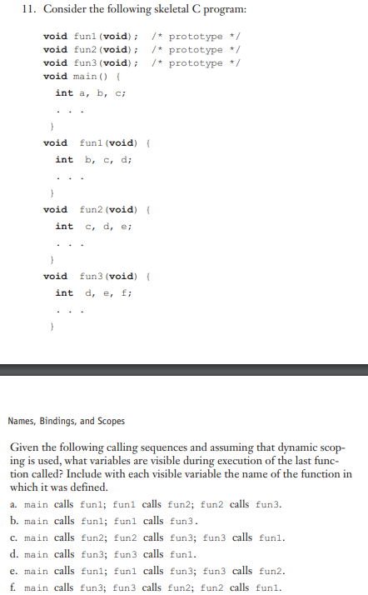

**Variables Visible** **Defined**

a:

a main

b fun1

c fun2

d fun3

e fun3

f fun3

b:

a main

b fun1

c fun1

d fun3

e fun3

f fun3

c:

a main

b fun1

c fun1

d fun1

e fun3

f fun3

d:

a main

b fun1

c fun1

d fun1

e fun3

f fun3

e:

a main

b fun1

f fun3

c fun2

d fun2

e fun2

f:

a main

b fun1

c fun2

d fun2

e fun2

f fun3